LARESSA BANKING SYSTEM REPORT

INTRODUCTION
Our banking system is a secure, user-friendly platform designed to manage customer accounts, process transactions, and provide basic banking services. The banking system allows customers to open an account, to make deposits in all accounts they hold, and it also ensures interest is paid to the customer.i.e.5% monthly for an investment account and 0.05% for a savings account.

SYSTEM OVERVIEW
Our banking system is designed to provide seamless banking experience for customers and administrators. The system allows users to:
- Create and manage accounts
- Perform transactions (deposits, withdrawals, transfers)
- View account balances and transactions history
- Manage account settings and security
The system caters to two primary user types:
- Customers: Individual users who can manage their accounts and perform transactions.
- Administrators: Bank staff who can manage customer accounts, process transactions, and generate reports.

Here’s a screenshot of the banking system: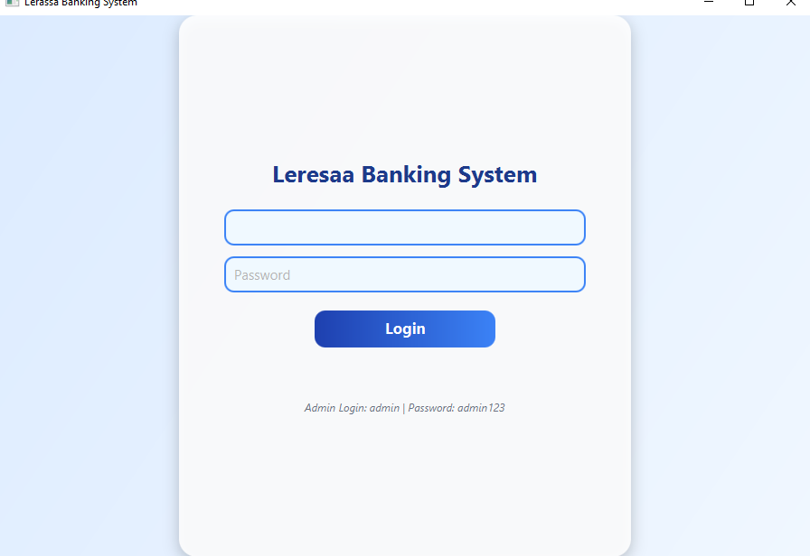

DESIGN AND ARCHITECTURE
Our banking system was designed using java, following a Model-View controller (MVC) pattern. Here is a breakdown:
- Core Model Implementation: Designed the core banking model including classes for accounts, transactions, and users.
- GUI Design and implementation: Created a user-friendly interface for customers and admins to interact with the system.
- Controller Implementation: Implemented business logic for account management, transactions, and security.
- Database connectivity: Connected the system to a database for storing user data and transactions.
- Module Integration and Testing: Integrated all components and performed thorough testing to ensure smooth functionality.
Using java and MVC helped keep the code organized and maintainable.

KEY FEATURES
Our banking system offers the following key features:
- Account Management: Create, view, and manage customer accounts accounts
- Transaction processing: Perform deposits,withdrawals,and transfers
- Balance enquiry: View current account balances
- Transaction History: View past transactions
- Security: Secure login and authorization for customers and admins
- Admin controls: Manage customers’ accounts, view reports, and perform admin tasks
Here is the screenshot of the banking system :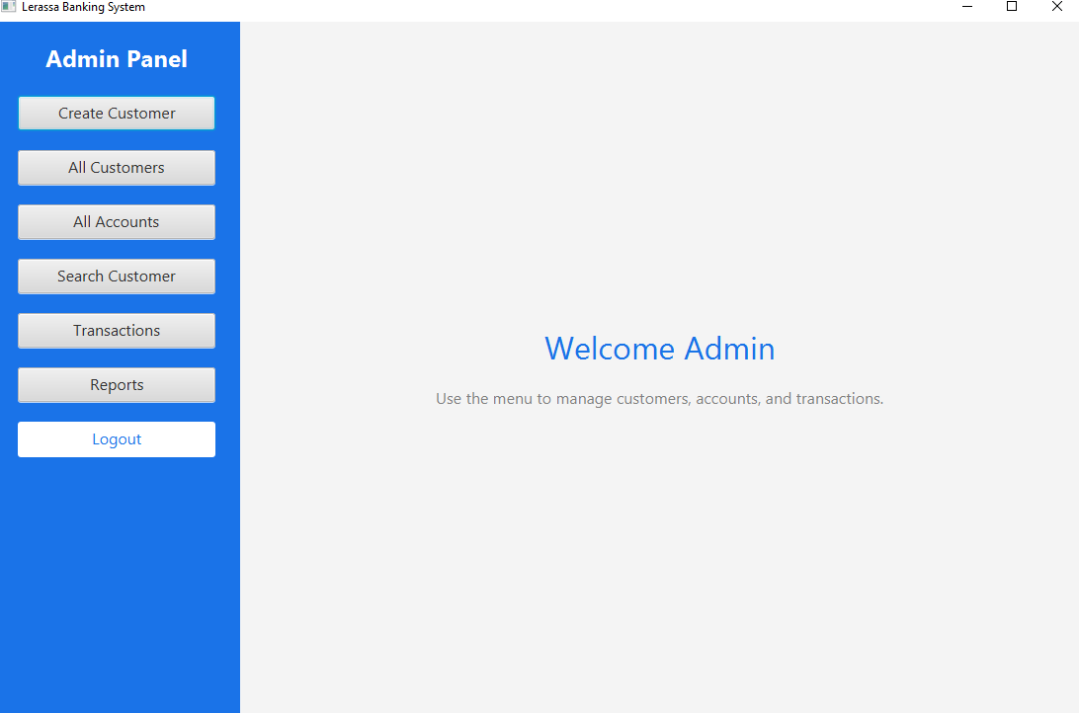

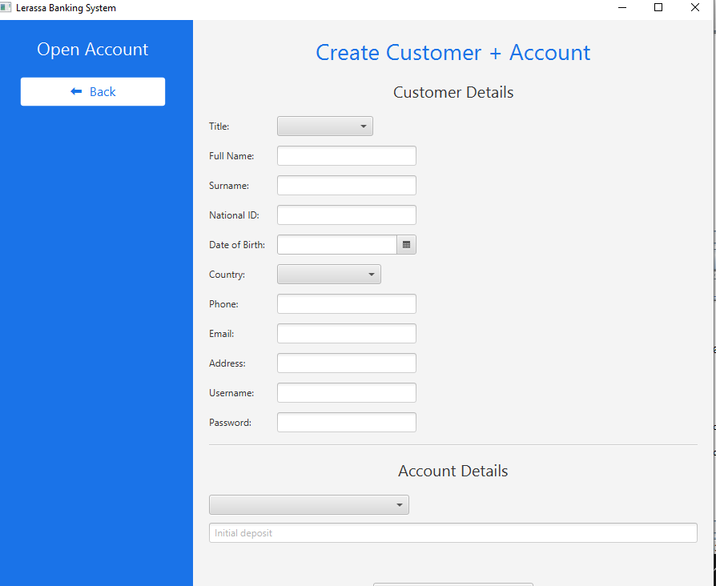

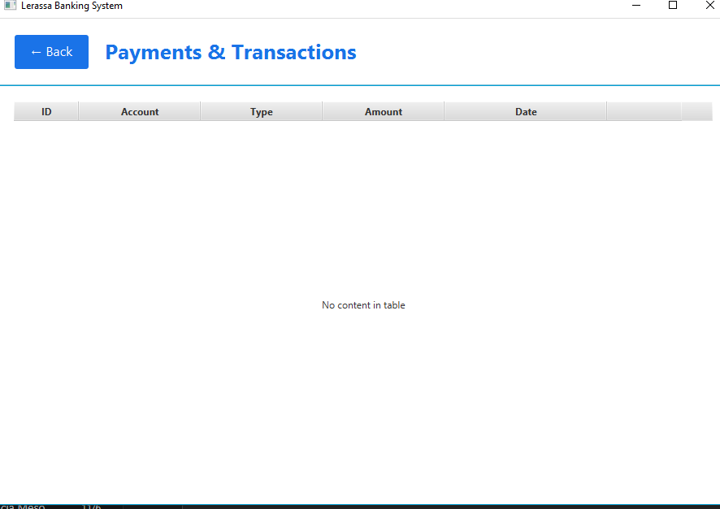

This is the dashboard of our banking system :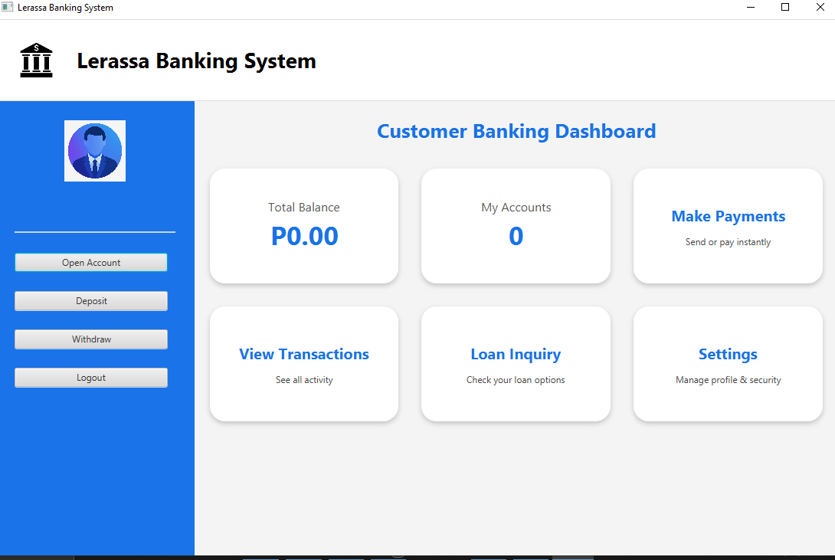

IMPLEMENTATION CHALLENGES
During the development of the LARESSA BANKING SYSTEM, we faced several challenges:
- Database connectivity: Ensuring secure and efficient connections to the database was crucial.
- User Authentication: Implementing robust security measures to protect user data was a top priority.
- GUI design: Creating an intuitive and user-friendly interface was essential for good user experience.
- Transaction Handling: managing transactions accurately and efficiently required careful planning.
These challenges were addressed through:
- Through testing and debugging
- Implementing best practices for security and performance
- Collaborating with team members to resolve issues

FUTURE ENHANCEMENTS

To further improve the Laressa Banking System, I plan to:
- Implement mobile banking: Develop a mobile app for on-the-go banking
- Add Online Payment Gateway: Enable online bill payments and transactions
- Enhance security measures: Implement two-factor authentication and encryption
- Improve Analytics and Reporting: Provide more detailed reports for admins

These enhancements will improve user experience, security, and overall system functionality.

CONCLUSION
The Laressa Banking System provides a solid foundation for managing banking operations. With its user-friendly interface and robust features, it meets the needs of both customers and admins. Through this project, I gained valuable experience in java development and database management.
Key Takeaways:
- Importance of thorough testing and debugging
- Need for robust security measures
- Value of collaboration and communication in team projects

